

**Title: eCoaching Log**

**Technical Requirements**

**Version 1.5**

|  |  |  |
| --- | --- | --- |
| Last Revision | Last Review | Description |
| 01/23/2014 |  | Brian Coughlin |
| 2/28/2014 |  | Brian Coughlin |
| 3/12/2014 |  | Brian Coughlin |
| 3/26/2014 |  | Brian Coughlin |
| 4/10/2014 |  | Brian Coughlin |
| 4/24/2014 |  | Brian Coughlin |

Prepared by: Brian Coughlin Date: 01/23/2014

Department, Location: BCC R&T – Oakdale

Approved by: Date:

| **Date** | **Change History Log**  **Change Description** | **Author** |
| --- | --- | --- |
| 01/23/2014 | Initial Draft | Brian Coughlin |
| 2/28/2014 | Removed GetDate(+7) in inactivations SCR 12330 Section VI | Brian Coughlin |
| 3/12/2014 | Updated Active and End_Date for rehired employees per SCR 12265 Section II | Brian Coughlin |
| 3/26/2014 | Added suggestions from Dev review and WTTI* Job Code from SCR12467 Section IV | Brian Coughlin |
| 4/11/2014 | Added Emp_Program and Start Date to the hierarchy table SCR 12407 | Brian Coughlin |
| 4/24/2014 | Updated the Requirements for SCRs 12483 (II #53, #58, VI, VII #13,#21)& 12495 (III E.) update eCL record to reflect appended score and note field & move the eCoaching Log application from sharepoint to the desktop | Brian  Coughlin |

Contents

I. Product Description 3

II. Customer Requirements 5

III. Program Requirements 30

IV. Layouts 31

V. Email Format 42

VI. Outliers (Data Feed\Form Entry) 42

VIII. Other System Attributes 57

IX. Method for Change Management 59

# Product Description

Project: eCoaching Log

Project Purpose: The eCoaching Log (eCL) is an internal Vangent process designed for the entry and storage of the coaching notes that supervisors, managers, Advanced Resolution Center (ARC) CSRs and quality leads make regarding CSR performance. These notes are gathered through escalations, floor walking, training, quality monitors. It also provides a repository of coaching notes to generate reports for management. The coaching notes will be retained for 3 years.

The eCoaching Log contains a component for CSRs to have the ability to comment on, or simply acknowledge the coaching comments entered by the supervisor or manager. The eCoaching Log VIP site establishes consistency and ease of use in our coaching notes process along with providing historical coaching data for all CSRs.

The central effort here involves porting the existing InfoPath based eCoaching log to an .NET/SQL Server platform. This will allow for improved performance and increased data capacity. The interface will utilize heirarchy information defined in Peoplesoft and eWFM.

The text (comments) fields in the database will need to be periodically scanned for PHI/PII data, in accordance with BCC Security Policy and Procedures.

The CSR/Supervisor hierarchical relationship comes from WFM, the HR/Peoplesoft group maintains Supervisor/Manager relationship. If Hierarchy information is missing in Coaching Logs received within the last 30 days, it will be updated with information from the WFM Employee Information table.

Many CSR names contain apostrophes which need to be removed in the database tables as well as the IQS feeds. They need to be retained in email addresses so those will be converted to double apostrophes. This has been completed for database functionality and security.

The comma delimiter in the IQS feed was replaced with a pipe delimiter (|) in order to maintain the punctuation integrity in the data.

From the dashboards, clicking on an eCoaching Log should open the log in a child window. With this functionality, the filter choices in the parent dashboard window are retained after the log window is closed.

Authentication to the eCL tab is done by validating the users LAN ID against a hierarchy table which is populated by Peoplesoft and eWFM based data. The LAN ID comes from the Peoplesoft feed. This replaces the previous Active Directory check, because there are now two disparate Actived Directory systems. Due to weekly AD migration of users the production database is updated to convert vngt\ LAN IDs to the new ad\ LAN IDs, so that these migrated users can access the eCoaching system.

ECLs are not maintained for subcontractors and records that are not able to be mapped to a user are rejected,.

|  |  |  |
| --- | --- | --- |
|  | | |
|  |  |  |
|  |  | | |
|  |  | | |

Document Purpose: To provide technical specifications the eCoaching Log.

Project Team: See table below.

| **Name** | **Role** |
| --- | --- |
| Brian Dye | Program Manager |
| John Tiongson | Analyst |
| Tim Queen | Project Manager – Engineering |
| Jourdain Augustin | Engineering |
| Susmitha Palacherla | Engineering |
| Brian Coughlin | Requirements and Testing |
| Bill Leferink | Engineering |

# Customer Requirements

Database Schema

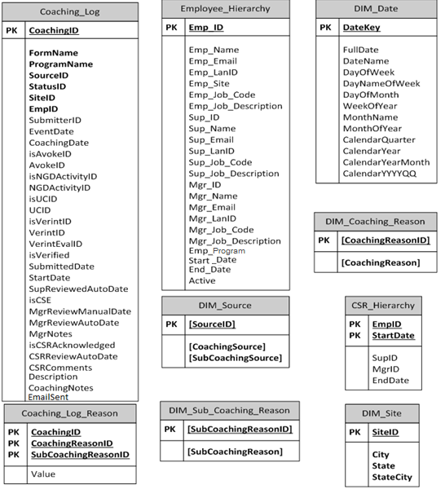

Data Definition

|  |  |  |  |  |  |  |
| --- | --- | --- | --- | --- | --- | --- |
| **#** | **REQUIREMENT** | **Type** | **RELATED REQUIREMENTS** | **COMMENTS** | |  |
|  | CoachingID | Whole Number (integer) |  | On submit.  Coaching Log Primary Key  FK to Coaching_Log_Reason | |  |
|  | FormName | Text (string) |  | On submit, concatenates form name and ID eCL-[strCSR]-[numID].  Coaching_Log | |  |
|  | StatusID | Whole Number (integer) | New | Overall status of form. (AUTO)  Coaching_Log | |  |
| Completed |  |
| Pending CSR Review |  |
| Pending Manager Review |  |
| Pending Supervisor Review |  |
| Pending Acknowledgment |  |
|  | EventDate | Date (date) |  | Indirect form: Date of event  Coaching_Log | |  |
|  | CoachingDate | Date (date) |  | Direct form: Date of coaching  Coaching_Log | |  |
|  | SubmitterID | Text (string) |  | Submitter LAN ID  Coaching_Log | |  |
|  | EmpID | Whole Number (integer) |  | CSR Employee ID  Coaching_Log  FK to Employee_Hierarchy  FK to CSR_Hierarchy | |  |
|  | SiteID | Whole Number (integer) |  | CSR Site  The site where the scorecard is created. Valid site IDs are:  SiteID City  1 Bogalusa  2 Boise  3 Brownsville  4 Chester  5 Coralville  6 Corbin  7 Hattiesburg  8 Houston  9 London  10 Lawrence  11 Layton  12 Lynn Haven  13 Pearl  14 Phoenix  15 Riverview  16 Sandy  17 Waco  18 Winchester  20 Arlington  Coaching_Log  FK to Dim_Site | |  |
|  | isUCID | True/False (boolean) | True/False | Universal Call ID decision field.  Coaching_Log | |  |
|  | UCID | Text (string) |  | Universal Call ID  Coaching_Log | |  |
|  | isVerintID | True/False (boolean) | True/False | VERINT Monitor decision field.  Coaching_Log | |  |
|  | VerintID | Text (string) |  | VERINT Contact/Journal Number  Coaching_Log | |  |
|  | isAvokeID | True/False (boolean) | True/False | Avoke decision field.  Asscociated with Behavioral Analytics Monitor  Coaching_Log | |  |
|  | AvokeID | Text (string) |  | Associated with Behavioral Analytics ID  Coaching_Log | |  |
|  | isNGDActivityID | True/False (boolean) | True/False | NGD Activity ID decision field.  Coaching_Log | |  |
|  | NGDActivityID | Text (string) |  | NGD Activity ID  Coaching_Log | |  |
|  | isVerified | True/False (boolean) | True/Default: False | Verification of information before submission of data.  Coaching Log | |  |
|  | SubmittedDate | Date and Time (datetime) |  | Date and Time Record is Loaded  Coaching Log | |  |
|  | StartDate | Date and Time (datetime) |  | Date and Time initial form load (Same as Submitted Date)  For IQS this is the same as the IQS Evaluation Date  This is the driver for identifying the Hierarchy  Coaching Log  FK to CSR_Hierarchy | |  |
|  | SupReviewedAutoDate | Date and Time (datetime) |  | Indirect: Date and Time [strCSRSup] reviewed form.  From form submit.  Coaching Log | |  |
|  | isCSE | True/False (boolean) | True/False | Verification of Customer Service Escalation by [strCSRMgr]  Coaching Log | |  |
|  | MgrReviewManualDate | Date and Time (datetime) |  | Date and Time [strCSRMgr] opened and reviewed form when [isCSE] ≠ True.  From Submit.  Coaching Log | |  |
|  | MgrReviewAutoDate | Date and Time (datetime) |  | Date and Time [strCSRMan] reviewed form.  From form submit.  Coaching Log | |  |
|  | MgrNotes | Text (string) |  | [StrCSRMgr] Explanation for [strCSR] and [strCSRSup] with reasons why this is not a CSE.  Coaching Log | |  |
|  | isCSRAcknowledged | True/False (boolean) | True/False | [strCSR] acknowledgement they have read and understand all the information provided in the eCL.  Coaching Log | |  |
|  | CSRReviewAutoDate | Date and Time (datetime) |  | Date and Time [strCSR] reviewed form.  From form submit.  Coaching Log | |  |
|  | txtCSRComments | Text (string) |  | [strCSR] comments and feedback.  Coaching Log | |  |
|  | SourceID | Whole Number (integer) |  | ID representing Coaching Source and Sub Coaching Source  Coaching_Log  FK to Dim_Source | |  |
|  | Verint_EvalID | Text (string) |  | IQS/Verint Details Table  Coaching_Log | |  |
|  | ProgramName | Text (string) | Medicare or Marketplace | Coaching_Log  All historical data prior to 6/1/2013 is mapped to Medicare. The 1 Multicode is used to determine Medicare or Marketplace for historical data after 6/1/2013. | |  |
|  | Emp_Name | Text (string) |  | CSR Full Name (Last, First MI)  Employee_Hierarchy | |  |
|  | Emp_Email | Text (string) |  | CSR Email Address  Employee_Hierarchy | |  |
|  | Emp_LanID | Text (string) |  | CSR LAN ID  Employee_Hierarchy | |  |
|  | Emp_Site | Text (string) |  | Name of site where employee is is located  Employee_Hierarchy | |  |
|  | Emp_Job_Code | Text (string) |  | Peoplesoft Job Code for the employee  Employee_Hierarchy | |  |
|  | Emp_Job_Description | Text (string) |  | Employee’s job description  Employee_Hierarchy | |  |
|  | SupID | Whole Number (integer) |  | Sup Employee ID  Employee_Hierarchy  FK to CSR_Hierarchy | |  |
|  | Sup_Email | Text (string) |  | Sup Email Address  Employee_Hierarchy | |  |
|  | Sup_LanID | Text (string) |  | Sup LAN ID  Employee_Hierarchy | |  |
|  | Sup_Job_Code | Text (string) |  | Peoplesoft Job Code for the supervisor  Employee_Hierarchy | |  |
|  | Sup_Job_Description | Text (string) |  | Supervisor’s job description  Employee_Hierarchy | |  |
|  | MgrID | Whole Number (integer) |  | Manager’s Employee ID  Employee_Hierarchy  FK to CSR_Hierarchy | |  |
|  | Mgr_Email | Text (string) |  | Manager’s Email Address  Employee_Hierarchy | |  |
|  | Mgr_LanID | Text (string) |  | Manager’s LAN ID  Employee_Hierarchy | |  |
|  | Mgr_Job_Code | Text (string) |  | Peoplesoft Job Code for the manager  Employee_Hierarchy | |  |
|  | Mgr_Job_Description | Text (string) |  | Manager’s job description  Employee_Hierarchy | |  |
|  | Emp_Program | Text (string) | Marketplace/Medicare | Program as determined by WFM 1Multi code  Employee_Hierarchy | |  |
|  | Start_Date | Date and Time (datetime) |  | Employee’s Hire Date from Peoplesoft  Employee_Hierarchy | |  |
|  | End_Date | Date and Time (datetime) |  | Date the Employee left the company  When we receive a hierarchy file containing a rehired CSR, the End_Date will be updated to 99991231 and the Active status will change to A.  Employee_Hierarchy  FK to CSR_Hierarchy | |  |
|  | Active | Text (string) |  | Active status for the employee  When we receive a hierarchy file containing a rehired CSR, the End_Date will be updated to 99991231 and the Active status will change to A.  Employee_Hierarchy | |  |
|  | CoachingReasonID | Whole Number (integer) |  | ID representing the type of Coaching Reason  PK for Coaching_Log_Reason  FK to Dim_Sub_Coaching_Reason | |  |
|  | SubCoachingReasonID | Whole Number (integer) |  | ID representing the type of SubCoaching Reason  PK for Coaching_Log_Reason  FK to Dim_Coaching_Reason | |  |
|  | Description | Text (string) |  | Details for the reason for the coaching (Note: for IQS records this will also contain the QS Coaching Notes. The Summary of Call will be followed by a carriage return and the words COACHING NOTES)  Note: When IQS feeds are received, containing updated logs that are still Open in our system, this field will be updated to match the newest feed.  Coaching_Log | |  |
|  | CoachingNotes | Text (string) |  | Details from the coaching session including action plans developed.  Coaching_Log | |  |
|  | Value | Text (string) | Opportunity or Reinforcement | Coaching_Log_Reason | |  |
|  | CoachingSource | Text (string) |  | Direct/Indirect/OMR/IQS  Direct: What type of coaching are you doing today?  Indirect: How was the coaching opportunity identified?  DIM_Source | |  |
|  | SubCoachingSource | Text (string) |  | **Direct:**  Supervisor Coaching  Manager Coaching  Verint Quality Monitoring  Quality Call Listening  CMS Customer Call Listening  Leadership Listening  Walk-By  CSR Reported Issue  Training and Development  Other  IQS (This is system generated not in UI)  OMR (This is system generated not in UI)  **Indirect:**  Quality Specialist Coaching  Supervisor Coaching  Manager Coaching  Verint Quality Monitoring  Quality Call Listening  CMS Customer Call Listening  Leadership Listening  Walk-By  CSR Reported Issue  Training and Development  Other  OMR (This is system generated not in UI)  IQS (This is system generated not in UI)  DIM_Source | |  |
|  | CoachingReason | Text (string) |  | AHT (The amount of time a CSR takes to complete a beneficiary call.)  ARC Issue (Advanced Resolution Center Escalation)  Attendance (Being at your work station and available for duty on your regular scheduled days except for management excused absences and as defined by BCC policy H301)  BCC Process Procedure Issues (Any process procedure)  Current Coaching Initiative (These currently include RMAs, EE/MMs, DMEPOS, Short Calls(Mapped to Other: Specify reason under Question 4 below SubCoachingReason for historical data, new data uses the OMR Short Calls Inbound\Outbound SubCoachingReasons), Transferred calls, Canceled calls, Disenrollment, etc.  These can change periodically.)  Customer Service Escalation (A series of activities designed to enhance the level of customer satisfaction – that is, the feeling that a product or service has met the customer expectation.  (An issue in this case would be a failure to meet the above definition.)  Feedback (Feedback from another CSR through their manager or supervisor or feedback from CMS.)  HR Guideline Issues (Any abuse to the HR Guidelines)  OMR / Exceptions  Quality (Quality Call Monitoring)  Note: When IQS feeds are received, containing updated logs that are still Open in our system, this field will be updated to match the newest feed.  Recognition (Any positive reinforcement for CSRs like KUDOS.)  Schedule Adherence (Scheduled work time minus unapproved exceptions divided by scheduled work time.)  Secure Floor Violations (CSR not following the Secure Floor security requirements.)  DIM_Coaching_Reason | |  |
|  | SubCoachingReason | Text (string) |  | Blank row at the top of the dropdown list  Argues  Yells, screams  Uses Profanity of any kind  Uses derogatory/disrespectful words  Threatens caller  Intentionally disconnects caller instead of greeting caller and handling call.  Blind transfers caller  Encourages fraud  Verbally abusive  Inappropriate NGD Feedback  CSAT  Casework Adhoc requests from CMS  Casework Bene Letter  Casework CTM  Casework Inappropriate ARC Escalation  Casework ISG Escalation  Complaints Research  Special Projects  OMR: Cancelled Calls  OMR: Default Qualifiers  OMR: Open Calls  OMR: Short Calls - Inbound  OMR: Short Calls - Outbound  OMR: ACW  OMR: AHT  OMR: BCC Security and Privacy Incident Coaching  OMR: Inappropriate ACO Escalation  OMR: Inappropriate ARC Escalation  OMR: Inappropriate DME Escalation  OMR: Inappropriate EE/MM Escalation  OMR: Inappropriate NGD Feedback  OMR: ISG Consults  OMR: Low CSAT  OMR: NGD Inappropriate Transfer  OMR: Returned MAC Escalation  OMR: Scripts Logged  OMR: Transfers  Other: Specify reason under Question 4 below reason under Question 4 below  Exception Reporting Disenrollment  Exception Reporting Inappropriate Transfers  Exception Reporting PDP Complaints  Enters authorization error compromising PHI  Security and Privacy Incident  DIM_Sub_Coaching_Reason | |  |
|  | DateKey | Whole Number (integer) |  | DIM_Date | |  |
|  | FullDate | Date (datetime) |  | DIM_Date | |  |
|  | DateName | Text (string) |  | DIM_Date | |  |
|  | DayofWeek | Whole Number (integer) |  | DIM_Date | |  |
|  | DayNameOfWeek | Text (string) |  | DIM_Date | |  |
|  | DayOfMonth | Whole Number (integer) |  | DIM_Date | |  |
|  | WeekOfYear | Whole Number (integer) |  | DIM_Date | |  |
|  | MonthName | Text (string) |  | DIM_Date | |  |
|  | MonthOfYear | Whole Number (integer) |  | DIM_Date | |  |
|  | CalendarQuarter | Whole Number (integer) |  | DIM_Date | |  |
|  | CalendarYear | Whole Number (integer) |  | DIM_Date | |  |
|  | CalendarYearMonth | Text (string) |  | DIM_Date | |  |
|  | CalendarYYYYQQ | Text (string) |  | DIM_Date | |  |
|  | City | Text (string) |  | DIM_Site | |  |
|  | State | Text (string) |  | DIM_Site | |  |
|  | StateCity | Text (string) |  | DIM_Site | |  |
|  | EmailSent | True/False (boolean) | Default: False | Email has been sent to Supervisor\ Manager  Only for SubCoachingSource = Supervisor Coaching/Manager Coaching  Coaching Log | |  |
|  | H_Start_Date | Date and Time (datetime) | Date started reporting to Supervisor/Manager | CSR_Hierarchy | |  |
|  | H_Stop_Date | Date and Time (datetime) | Date last reported to Supervisor/Manager | CSR_Hierarchy | |  |
| **Notes:** Historical data that has strCoachReason_ShortCalls will be mapped to SubCoachingReason Other: Specify reason under Question 4 below reason under Question 4 below, because it has been replaced with the SubCoachingReasons OMR: Short Calls – Inbound and OMR: Short Calls – Outbound. Historical data that is missing SubCoachingReason will be mapped to Other: Specify reason under Question 4 below. Historical data that is missing hierarchical associations to supervisor or manager should use the current supervisor or manager. | | | | | | |
|  | User Interface Controls |  |  | |  |  |
|  | eCL Weekly Compliance Report | Email | Weekly view of completed forms and pending forms related to form timeframe completion requirements. | | Reports CCO, QA-OPS |  |
|  | eCL Monthly Compliance Report | Email | Monthly view of completed forms and pending forms related to form timeframe completion requirements. | | Reports BCC |  |
|  | eCL Monthly Coaching Reason Trend Analysis | Email | Monthly view of coaching reasons by form type, site, manager and source. | | Reports BCC |  |
|  | eCL Quarterly Coaching Reason Trend Analysis | Email | Quarterly view of coaching reasons by form type, site, manager and source of opportunity. | | Reports – BCC |  |
|  | Manager Dashboard | Web | Access to completed and pending eCL forms for CSRs and Superiors on team. | | Reports – CCO Managers |  |
|  | Supervisor Dashboard | Web | Access to completed and pending eCL forms for CSRs on team. | | Reports – CCO Supervisors |  |
|  | CSR Dashboard | Web | Access to completed and pending eCL forms. | | Reports – CCO CSRs |  |
|  | eCL Reporting Dashboard | Web | Self-service tool with cross site and team access to completed eCL form data. | | Reports |  |
|  | For non-Customer Service Escalations, CSRs will receive an e-mail notifying them that they have a pending eCoaching log to review. The e-mail contains a link to the eCoaching Log.  The CSR can use the e-mail link to access the eCoaching Log to review the coaching notes with his or her supervisor .  If it is a CSE the manager will write the Action Plan and assist in Coaching the CSR. |  | For IQS Monitors, CSRs and Supervisors do need to acknowledge the log. New monitors in the feed will generate new eCoaching logs and appealed monitors will update existing eCoaching logs. | |  |  |
|  | My Pending eCoaching Logs | Coaching Logs List\Dashboard | See My Recent Submissions List for field definitions | | CSR Interface |  |
|  | My Completed eCoaching Logs | Coaching Logs List\Dashboard | See My Recent Submissions List for field definitions | | CSR Interface |  |
|  | Coaching Notes | Coaching Acknowledgment Form (Static Text) | Specific coaching notes for this eCoaching Log record | | CSR Interface |  |
|  | “I have read and understand all the information provided on this eCoaching Log” | Coaching Acknowledgment Form (CheckBox) |  | | CSR Interface |  |
|  | Comments | Coaching Acknowledgment Form (Text Box) | CSRs comments regarding this coaching record | | CSR Interface |  |
|  | Submit | Coaching Acknowledgment Form (Button) | Submits the Form | | CSR Interface |  |
|  | “Select the CSR’s Name” | Submit Record Form (Drop Down List Box) | List is populated from Peoplesoft based on employees having “Service Rep” in their job title. | | CSR Interface |  |
|  | “CSR’s Supervisor Name” | Submit Record Form (List Box) | Auto Populated from PeopleSoft Heirarchy | | Supervisor/Support Staff Interface |  |
|  | “CSR’s Manager Name” | Submit Record Form (List Box) | Auto Populated from Peoplesoft and eWFM Heirarchy | | Supervisor/Support Staff Interface |  |
|  | “Select the CSR’s Site” | Submit Record Form (Drop Down List Box) |  | | Supervisor/Support Staff Interface |  |
|  | “Will you be delivering the coaching session? | Submit Record Form (Radio Buttons) | Yes, I will be delivering the coaching session.  No, I will not be delivering the coaching session. | | Supervisor/Support Staff Interface |  |
|  | Next | Submit Record Form (Button) | Inactive until required fields are complete. Required:CSR site/name and who will deliver coaching. | | Supervisor/Support Staff Interface |  |
|  | “Enter / Select the date of coaching” | Submit Record Detail Form (Calendar\Text) | Note: Can’t enter future dates | | Supervisor/Support Staff Interface |  |
|  | “Is this a Customer Service Escalation?” | Submit Record Detail Form (Radio Buttons) | Yes/No | | Supervisor/Support Staff Interface |  |
|  | “Select the type of coaching from the categories below” | Submit Record Detail Form | Opportunities are defined as an interaction where the CSR has an opportunity to improve their performance.  Reinforcement is an interaction where the CSR is meeting expectations and we want to reinforce positive behaviors. | | Supervisor/Support Staff Interface |  |
|  | AHT | Submit Record Detail Form (Checkbox/Radio Buttons / Dropdown List Box) | Opportunity or Reinforcement   * Other: Specify reason under Question 4 below | | Supervisor/Support Staff Interface |  |
|  | ARC Issue | Submit Record Detail Form (Checkbox/Radio Buttons / Dropdown List Box) | Opportunity or Reinforcement   * Casework Adhoc requests from CMS * Casework Bene Letter * Casework CTM * Casework Inappropriate ARC Escalation * Casework ISG Escalation * Complaints Research * Special Projects * Other: Specify reason under Question 4 below | | Supervisor/Support Staff Interface |  |
|  | Attendance | Submit Record Detail Form (Checkbox/Radio Buttons / Dropdown List Box) | Opportunity or Reinforcement   * Other: Specify reason under Question 4 below | | Supervisor/Support Staff Interface |  |
|  | BCC Process Procedure Issues | Submit Record Detail Form (Checkbox/Radio Buttons / Dropdown List Box) | Opportunity or Reinforcement   * Security and Privacy Incident * Other: Specify reason under Question 4 below | | Supervisor/Support Staff Interface |  |
|  | Current Coaching Initiatives | Submit Record Detail Form (Checkbox/Radio Buttons / Dropdown List Box) | Opportunity or Reinforcement   * Other: Specify reason under Question 4 below | | Supervisor/Support Staff Interface |  |
|  | Customer Service Issue | Submit Record Detail Form (Checkbox/Radio Buttons / Dropdown List Box) | Opportunity or Reinforcement   * Argues * Blind transfers call * Encourages fraud * Enters authorization error compromising PHI * Intentionally disconnects caller * Threatens caller * Uses derogatory/disrespectful words * Uses profanity of any kind * Verbally abusive * Yells, screams * Other: Specify reason under Question 4 below | | Supervisor/Support Staff Interface |  |
|  | Feedback (CSR And Customer) | Submit Record Detail Form (Checkbox/Radio Buttons / Dropdown List Box) | Opportunity or Reinforcement   * Inappropriate NGD Feedback * Other: Specify reason under Question 4 below | | Supervisor/Support Staff Interface |  |
|  | HR Guideline Issues | Submit Record Detail Form (Checkbox/Radio Buttons / Dropdown List Box) | Opportunity or Reinforcement   * Other: Specify reason under Question 4 below | | Supervisor/Support Staff Interface |  |
|  | OMR Exceptions | Submit Record Detail Form (Checkbox/Radio Buttons / Dropdown List Box) | Opportunity or Reinforcement   * Exception Reporting Disenrollment * Exception Reporting Inappropriate Transfers * Exception Reporting PDP Complaints * OMR: ACW * OMR: AHT * OMR: BCC Security and Privacy Incident Coaching * OMR: Cancelled Calls * OMR: Default Qualifiers * OMR: Inappropriate ACO Escalation * OMR: Inappropriate ARC Escalation * OMR: Inappropriate DME Escalation * OMR: Inappropriate EE/MM Escalation * OMR: Inappropriate NGD Feedback * OMR: ISG Consults * OMR: Low CSAT * OMR: NGD Inappropriate Transfer * OMR: Open Calls * OMR: Returned MAC Escalation * OMR: Scripts Logged * OMR: Short Calls – Inbound * OMR: Short Calls - Outbound * OMR: Transfers | | Supervisor/Support Staff Interface |  |
|  | Quality | Submit Record Detail Form (Checkbox/Radio Buttons / Dropdown List Box) | Opportunity or Reinforcement   * CSAT * Other: Specify reason under Question 4 below | | Supervisor/Support Staff Interface |  |
|  | Recognition | Submit Record Detail Form (Checkbox/Radio Buttons / Dropdown List Box) | Opportunity or Reinforcement   * Other: Specify reason under Question 4 below | | Supervisor/Support Staff Interface |  |
|  | Secure Floor Violations | Submit Record Detail Form (Checkbox/Radio Buttons / Dropdown List Box) | Opportunity or Reinforcement   * Other: Specify reason under Question 4 below | | Supervisor/Support Staff Interface |  |
|  | Schedule Adherence | Submit Record Detail Form (Checkbox/Radio Buttons / Dropdown List Box) | Opportunity or Reinforcement   * Other: Specify reason under Question 4 below | | Supervisor/Support Staff Interface |  |
|  | “Provide details of the behavior to be coached” | Submit Record Detail Form (Text Box) |  | | Supervisor/Support Staff Interface |  |
|  | Direct:  “Provide the details from the coaching session including action plans developed” | Submit Record Detail Form (Text Box) |  | | Supervisor/Support Staff Interface |  |
|  | “How was the coaching opportunity identified?” | Submit Record Detail Form (Dropdown List Box) |  | | Supervisor/Support Staff Interface |  |
|  | Indirect Non CSE  “Is there a Call Record or NGD ID associated with this coaching?”  All Others  “Is there a Call Record associated with this coaching?” | Radio/Drop Down List Box/Free Form text | Yes/No | |  |  |
|  | “I have verified that all the information on this form is true and complete to the best of my knowledge” | Submit Record Detail Form (CheckBox) |  | |  |  |
|  | Back | Submit Record Detail Form (Button) | Return to the previous page | | Supervisor/Support Staff Interface |  |
|  | Submit | Submit Record Detail Form (Button) | Once the Submit button is pressed you cannot make edits.  For non Customer Service Escalations, an email is automatically sent to the CSR alerting them of the eCL record and providing a link to it.  For Customer Service Escalations, the form is routed to the Manager to determine whether it’s a CSE or not. If it is, the manager adds details of why it’s a CSE and action plans. The CSR will be coached by the Manager and Supervisor in this case. | |  |  |
|  | Name | My Recent Submissions List  (WebLink) | CoachingID  Opens Acknowledgement Form for the Record | | Supervisor/Support Staff Interface |  |
|  | StrFormStatus | My Recent Submissions List  (Static Text Field) | Status (Pending\Completed)  It should be based on the value of strCoachReason_CSE. If strCoachReason_CSE is Not Null, the StrFormStatus is set to Pending Manager review and the Opportunity for CSE is marked | | Supervisor/Support Staff Interface |  |
|  | SubmittedDate | My Recent Submissions List  (Static Text Field) | Date Loaded  Primary Sorting field in Reverse Chronological Order  Default is last 30 days. | | Supervisor/Support Staff Interface |  |
|  | My Pending eCoaching Logs | Coaching Logs List\Dashboard | See My Recent Submissions List for field definitions  Note: at the supervisor level, the hierarchy shows logs associated with each CSR in a tree view by alphabetical order | | Supervisor/Support Staff Interface |  |
|  | My CSRs Pending eCoaching Logs | Coaching Logs List\Dashboard | See My Recent Submissions List for field definitions  Note: at the supervisor level, the hierarchy shows logs associated with each CSR in a tree view by alphabetical order | | Supervisor/Support Staff Interface |  |
|  | My Completed eCoaching Logs | Coaching Logs List\Dashboard | See My Recent Submissions List for field definitions  Note: at the supervisor level, the hierarchy shows logs associated with each CSR in a tree view by alphabetical order | | Supervisor/Support Staff Interface |  |
|  | For Customer Service Escalations (CSEs), the form is routed to the manager via email to confirm whether the event was a CSE. If the manager confirms that the event was a CSE, he or she will enter an action plan in the coaching notes. Once completed, a coaching session with the CSR, manager, and supervisor will occur |  |  | | Supervisor/Support Staff Interface |  |
|  | Coaching Reasons | Review Pending Records Form  (Static Text) |  | | Manager Interface |  |
|  | Details of the behavior being coached | Review Pending Records Form  (Static Text) |  | | Manager Interface |  |
|  | Coaching Notes | Review Pending Records Form  (Static Text) |  | | Manager Interface |  |
|  | “Is the Coaching opportunity a confirmed Customer Service Escalation?” | Review Pending Records Form (Radio Buttons)  Mark “Yes” if it’s determined to be a CSE or change to “No” if it’s not a CSE |  | | Manager Interface |  |
|  | “Enter /Select the date of coaching:” | Review Pending Records Form  (Calendar Control) |  | | Manager Interface |  |
|  | Direct:  “Provide the details from the coaching session including action plans developed” | Review Pending Records Form  (Text Box) |  | | Manager Interface |  |
|  | Back | Review Pending Records Form  (Button) | Return to previous page | | Manager Interface |  |
|  | Submit | Review Pending Records Form  (Button) | Once the Submit button is pressed you cannot make edits.  The form is routed to the CSR for review.  If status is Pending  CSR Review  Pending Manager Review  Pending Supervisor Review  An email is automatically sent  See Workflow below | |  |  |
|  | My Pending eCoaching Logs | Coaching Logs List\Dashboard | See My Recent Submissions List for field definitions  Note: at the manager level, the hierarchy shows logs associated with each Supervisor in a tree view by alphabetical order | | Manager Interface |  |
|  | My Completed eCoaching Logs | Coaching Logs List\Dashboard | See My Recent Submissions List for field definitions  Note: at the manager level, the hierarchy shows logs associated with each Supervisor in a tree view by alphabetical order | | Manager Interface |  |
|  | If the user needs more information of what type of content goes into each field, he or she may hover over the information icon. | All Forms  (ToolTips) |  | | Manager Interface |  |
| 65 | Generic (Quality/Training Job Title) Dashboard | Web | Access to completed and pending eCL forms for CSRs on team with Title “Welcome to the eCL Dashboard”. | | All Users |  |

# - Unique identifier associated with the requirement allocated.

Top of Form

|  |  |  |
| --- | --- | --- |
| |  |  | | --- | --- | | |  | | --- | | Program RequirementsSupervisors must conduct at least one eCoaching session per weekPortability and accessibility to both the customer service representatives (CSRs), direct and subsequent supervisors, and managers.The eCoaching Log form is predominately displayed in the middle of the home page.The dashboard is filtered by each user so users cannot view other’s records unless authorized to do so.The CSR\Supervisor\Manager should access the My Submitted, Dashboard, and Historical Dashboards from the shortcut on their desktop. They can also view their Dashboard from the eCoaching Log Dashboard tab on the Performance Scorecard. The main page accessed from the desktop shortcut, has tabs for each (My Submitted, Dashboard, and Historical).Issues will be submitted to a central database for the Site Administrators to review and resolve. When submitting issues, users should include screenshots as an attachment, hyperlinks, form fields, and, if possible, try to replicate the issue. |   View in Web Browser  /sites/teams/CMS/CSR/eCoaching/help/_layouts/VisioWebAccess/VisioWebAccess.aspx?listguid={ListId}&itemid={ItemId}&DefaultItemOpen=1  0x0  0x1  FileType  vdw  255  Compliance Details  javascript:commonShowModalDialog(‘{SiteUrl}/_layouts/itemexpiration.aspx?ID={ItemId}&List={ListId}’, ‘center:1;dialogHeight:500px;dialogWidth:500px;resizable:yes;status:no;location:no;menubar:no;help:no’, function GotoPageAfterClose(pageid){if(pageid == ‘hold’) {STSNavigate(unescape(decodeURI(‘{SiteUrl}’))+’/_layouts/hold.aspx?ID={ItemId}&List={ListId}’); return false;} if(pageid == ‘audit’) {STSNavigate(unescape(decodeURI(‘{SiteUrl}’))+’/_layouts/Reporting.aspx?Category=Auditing&backtype=item&ID={ItemId}&List={ListId}’); return false;} if(pageid == ‘config’) {STSNavigate(unescape(decodeURI(‘{SiteUrl}’))+’/_layouts/expirationconfig.aspx?ID={ItemId}&List={ListId}’); return false;}}, null); return false;  0x0  0x1  ContentType  0x01  898  Edit in Browser  /_layouts/images/icxddoc.gif  /sites/teams/CMS/CSR/eCoaching/help/_layouts/formserver.aspx?XsnLocation={ItemUrl}&OpenIn=Browser&Source={Source}  0x0  0x1  FileType  xsn  255  Edit in Browser  /_layouts/images/icxddoc.gif  /sites/teams/CMS/CSR/eCoaching/help/_layouts/formserver.aspx?XmlLocation={ItemUrl}&OpenIn=Browser&Source={Source}  0x0  0x1  ProgId  InfoPath.Document  255  Edit in Browser  /_layouts/images/icxddoc.gif  /sites/teams/CMS/CSR/eCoaching/help/_layouts/formserver.aspx?XmlLocation={ItemUrl}&OpenIn=Browser&Source={Source}  0x0  0x1  ProgId  InfoPath.Document.2  255  Edit in Browser  /_layouts/images/icxddoc.gif  /sites/teams/CMS/CSR/eCoaching/help/_layouts/formserver.aspx?XmlLocation={ItemUrl}&OpenIn=Browser&Source={Source}  0x0  0x1  ProgId  InfoPath.Document.3  255  Edit in Browser  /_layouts/images/icxddoc.gif  /sites/teams/CMS/CSR/eCoaching/help/_layouts/formserver.aspx?XmlLocation={ItemUrl}&OpenIn=Browser&Source={Source}  0x0  0x1  ProgId  InfoPath.Document.4  255  View in Browser  /sites/teams/CMS/CSR/eCoaching/help/_layouts/xlviewer.aspx?id={ItemUrl}&DefaultItemOpen=1  0x0  0x1  FileType  xlsx  255  View in Browser  /sites/teams/CMS/CSR/eCoaching/help/_layouts/xlviewer.aspx?id={ItemUrl}&DefaultItemOpen=1  0x0  0x1  FileType  xlsm  255  View in Browser  /sites/teams/CMS/CSR/eCoaching/help/_layouts/xlviewer.aspx?id={ItemUrl}&DefaultItemOpen=1  0x0  0x1  FileType  xlsb  255 | |

# Layouts

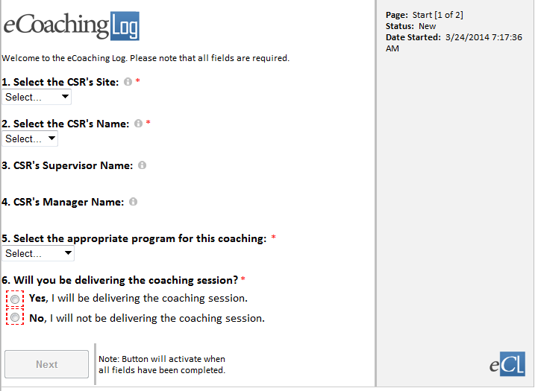

Direct Coaching - CSE

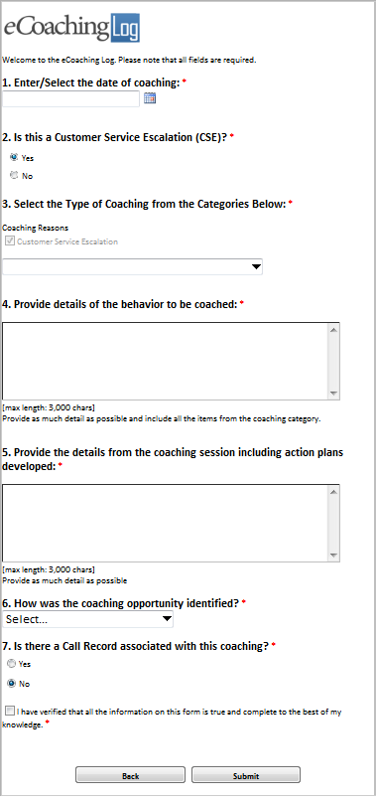

Customer Service Escalation:

* Argues
* Blind transfers call
* Encourages fraud
* Enters authorization error compromising PHI
* Intentionally disconnects caller
* Threatens caller
* Uses derogatory/disrespectful words
* Uses profanity of any kind
* Verbally abusive
* Yells, screams
* Other: Specify reason under Question 4 below

How was the coaching opportunity identified?

* CSR Reported Issue
* CMS Customer Call Listening
* Leadership Listening
* Manager Coaching
* Quality Call Listening
* Quality Specialist Coaching
* Supervisor Coaching
* Training and Development
* Verint Quality Monitoring
* Walk-By

Is there a Call Record associated with this coaching?

* Avoke
* NGD ID
* UCID
* Verint

Direct Coaching – Non CSE

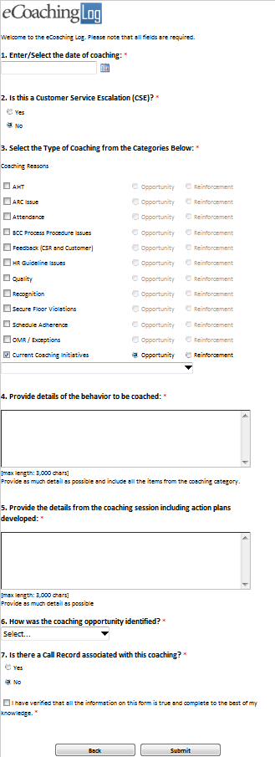

AHT:

* Other: Specify reason under Question 4 below

ARC Issue:

* Casework Adhoc requests from CMS
* Casework Bene Letter
* Casework CTM
* Casework Inappropriate ARC Escalation
* Casework ISG Escalation
* Complaints Research
* Special Projects
* Other: Specify reason under Question 4 below

Attendance:

* Other: Specify reason under Question 4 below

BCC Process Procedure Issues:

* Security and Privacy Incident
* Other: Specify reason under Question 4 below

Current Coaching Initiatives:

* Other Specify

Feedback (CSR and Customer):

* Inappropriate NGD Feedback
* Other: Specify reason under Question 4 below

HR Guideline Issues:

* Other: Specify reason under Question 4 below

OMR / Exceptions:

* Exception Reporting Inappropriate Transfers
* Exception Reporting PDP Complaints
* OMR: ACW
* OMR: AHT
* OMR: BCC Security and Privacy Incident Coaching
* OMR: Cancelled Calls
* OMR: Default Qualifiers
* OMR: Inappropriate ACO Escalation
* OMR: Inappropriate ARC Escalation
* OMR: Open Calls
* OMR: Short Calls – Inbound
* OMR: Short Calls - Outbound

Quality:

* CSAT
* Other: Specify reason under Question 4 below

Recognition:

* Other: Specify reason under Question 4 below

Secure Floor Violations:

* Other: Specify reason under Question 4 below

Schedule Adherence:

* Other: Specify reason under Question 4 below

Indirect Coaching CSE

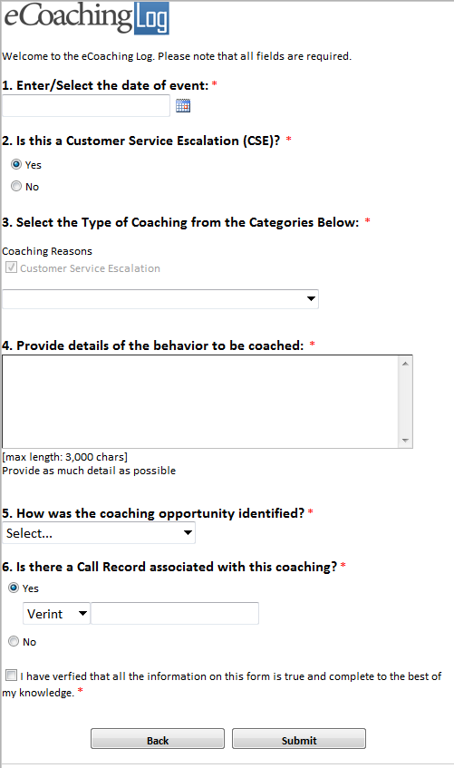

Customer Service Escalation:

* Argues
* Blind transfers call
* Encourages fraud
* Enters authorization error compromising PHI
* Intentionally disconnects caller
* Threatens caller
* Uses derogatory/disrespectful words
* Uses profanity of any kind
* Verbally abusive
* Yells, screams
* Other: Specify reason under Question 4 below

Indirect Coaching – Non CSE

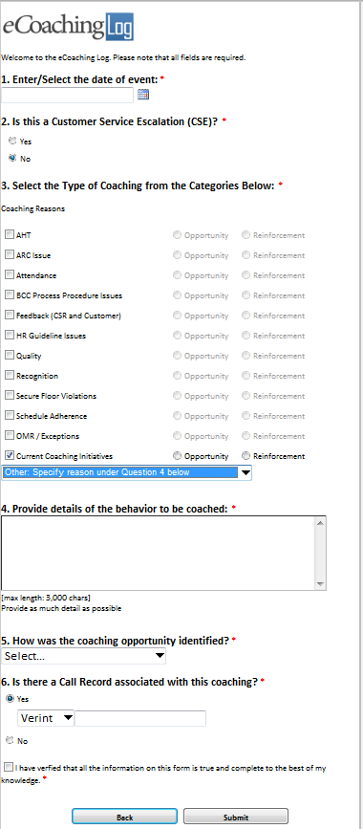

AHT:

* Other: Specify reason under Question 4 below

ARC Issue:

* Casework Adhoc requests from CMS
* Casework Bene Letter
* Casework CTM
* Casework Inappropriate ARC Escalation
* Casework ISG Escalation
* Complaints Research
* Special Projects
* Other: Specify reason under Question 4 below

Attendance:

* Other: Specify reason under Question 4 below

BCC Process Procedure Issues:

* Security and Privacy Incident
* Other: Specify reason under Question 4 below

Current Coaching Initiatives:

* Other Specify

Feedback (CSR and Customer):

* Inappropriate NGD Feedback
* Other: Specify reason under Question 4 below

HR Guideline Issues:

* Other: Specify reason under Question 4 below

OMR / Exceptions:

* Exception Reporting Inappropriate Transfers
* Exception Reporting PDP Complaints
* OMR: ACW
* OMR: AHT
* OMR: BCC Security and Privacy Incident Coaching
* OMR: Cancelled Calls
* OMR: Default Qualifiers
* OMR: Inappropriate ACO Escalation
* OMR: Inappropriate ARC Escalation
* OMR: Open Calls
* OMR: Short Calls – Inbound
* OMR: Short Calls - Outbound

Quality:

* CSAT
* Other: Specify reason under Question 4 below

Recognition:

* Other: Specify reason under Question 4 below

Secure Floor Violations:

* Other: Specify reason under Question 4 below

Schedule Adherence:

* Other: Specify reason under Question 4 below

**Dashboard Permissions Criteria:**

The following users will have access to the eCoaching Dashboards according to their employee job codes:

Main Dashboard

* CSR level users – WACS0*
* Supervisor level users - *40,WTTR12,WTTI*
* Manager Level users - *50, *60, *70, WISO*, WSTE*, WPPM*, WPSM*, WEEX*,WISY*
* Support Staff users – WSQE*, WACQ*

Main Dashboard Review:

* Users who are the CSR of the record
* Users who are the Supervisor of the record’s CSR in record or ooleany
* Users who are the Manager of the record’s CSR’s Supervisor in record or ooleany
* Users who are the submitter of the record (except for users who are in the database table “EC.Historical_Dashboard_ACL” table as an ARC CSR (Role = “ARC”) – WACS03

My Submitted:

* Supervisor level users - *40,WTTR12, WTTI*
* Manager Level users - *50, *60, *70, WISO*, WSTE*, WPPM*, WPSM*, WEEX*,WISY*
* Support Staff users – All other users except for users with CSR Job codes – WACS01, WACS02, WACS03

Historical Dashboard:

* Supervisor and above level users - *40, *50, *60, *70, WISO*, WSTE*, WPPM*, WPSM*, WSQE*, WACQ*, WEEX*,WISY*

Historical Dashboard Review:

* Supervisor and above level users - *40, *50, *60, *70, WISO*, WSTE*, WPPM*, WPSM*, WSQE*, WACQ*, WEEX*,WISY*
* Users who are in the database table “EC.Historical_Dashboard_ACL” table as an historical exception user (Role = “ECL”) can open any record

# CSR Dashboard

This dashboard allows the CSR to view their pending and completed eCLs.

|  |  |  |  |  |
| --- | --- | --- | --- | --- |
| **#** | **Section** | **Filter** | **Displayed Fields** | **Sort Options** |
| 1 | My Pending eCoaching Logs | CRS Name = current user  Role = CSR  strFormStatus = Pending CSR Review | FormID (w/Link to form), CSR Name, strFormStatus and Created Date | No Pagination (Show all records)  Show items in descending order from Created Date or Form ID |
| 2 | My Completed eCoaching Logs | CSR Name = current user  Role = CSR  strFormStatus = Completed | FormID (w/Link to form), CSR Name, Supervisor Name, Manager Name, strFormStatus and Created Date | Pagination = 20 records  Show items in descending order from Created Date or Form ID |

# Supervisor Dashboard

This dashboard allows the Supervisor to view their direct reports pending and completed as well as their own pending eCLs.

|  |  |  |  |  |
| --- | --- | --- | --- | --- |
| **#** | **Section** | **Filter** | **Displayed Fields** | **Sort Options** |
| 1 | My Pending eCoaching Logs | Supervisor Name = current user  Role = Supervisor  strFormStatus = Pending Supervisor Review  or strFormStatus =Pending Acknowledgment | FormID (w/Link to form), CSR Name, Supervisor Name, strFormStatus and Created Date | No Pagination (Show all records)  Show items in descending order from Created Date or Form ID |
| 2 | My Teams Pending eCoaching Logs | Supervisor Name = current user  Role = Supervisor  strFormStatus = Pending CSR Review and Pending Manager Review | FormID (w/Link to form), CSR Name, Supervisor Name, Manager Name, strFormStatus and Created Date | Pagination = 20 records  Show items in descending order from Created Date or Form ID  Group by = CSR Name |
| 3 | My Teams Completed eCoaching Logs | Supervisor Name = current user  Role = Supervisor  strFormStatus = Completed | FormID (w/Link to form), CSR Name, Supervisor Name, Manager Name, strFormStatus and Created Date | Pagination = 20 records  Show items in descending order from Created Date or Form ID  Group by = CSR Name |
| 4 | My Submitted eCoaching Logs | Submitter Name = current user  Role = Support Staff | FormID (w/Link to form), CSR Name, Supervisor Name, Manager Name, strFormStatus and Created Date | Pagination = 20 records  Show items in descending order from Created Date or Form ID  Group by = Manager Name then by Supervisor Name, strFormStatus and then by CSR Name |

# Manager Dashboard

This dashboard allows the Managers to view their direct reports pending and completed as well as their own pending eCLs.

|  |  |  |  |  |
| --- | --- | --- | --- | --- |
| **#** | **Section** | **Filter** | **Displayed Fields** | **Sort Options** |
| 1 | My Pending eCoaching Logs | Supervisor Name = current user  Role = Supervisor  strFormStatus = Pending Manager Review | FormID (w/Link to form), CSR Name, Supervisor Name, strFormStatus and Created Date | Pagination = 10 records  Show items in descending order from Created Date or Form ID  Group by = Supervisor Name then by CSR Name |
| 2 | My Teams Pending eCoaching Logs | Manager Name = current user  Role = Manager  strFormStatus = Pending CSR Review, Pending Supervisor Review, Pending Acknowledgment | FormID (w/Link to form), CSR Name, Supervisor Name, Manager Name, strFormStatus and Created Date | Pagination = 20 records  Show items in descending order from Created Date or Form ID  Group by = Supervisor Name then by CSR Name |
| 3 | My Teams Completed eCoaching Logs | Manager Name = current user  Role = Manager  strFormStatus = Completed | FormID (w/Link to form), CSR Name, Supervisor Name, Manager Name, strFormStatus and Created Date | Pagination = 20 records  Show items in descending order from Created Date or Form ID  Group by = Supervisor Name then by CSR Name |
| 4 | My Submitted eCoaching Logs | Submitter Name = current user  Role = Support Staff | FormID (w/Link to form), CSR Name, Supervisor Name, Manager Name, strFormStatus and Created Date | Pagination = 20 records  Show items in descending order from Created Date or Form ID  Group by = Manager Name then by Supervisor Name, strFormStatus and then by CSR Name |

# Quality\Training Supervisor Dashboard

This dashboard allows the Quality or Training Supervisor to view their direct reports pending and completed as well as their own pending eCLs. The title of the Dashboard is “Welcome to the eCL Dashboard”.

|  |  |  |  |  |
| --- | --- | --- | --- | --- |
| **#** | **Section** | **Filter** | **Displayed Fields** | **Sort Options** |
| 1 | My Pending eCoaching Logs | Supervisor Name = current user  Role = Supervisor  strFormStatus = Pending Supervisor Review  or strFormStatus = Pending Acknowledgment | FormID (w/Link to form), CSR Name, Supervisor Name, strFormStatus and Created Date | No Pagination (Show all records)  Show items in descending order from Created Date or Form ID |
| 2 | My Teams Pending eCoaching Logs | Supervisor Name = current user  Role = Supervisor  strFormStatus = Pending CSR Review and Pending Manager Review | FormID (w/Link to form), CSR Name, Supervisor Name, Manager Name, strFormStatus and Created Date | Pagination = 20 records  Show items in descending order from Created Date or Form ID  Group by = CSR Name |
| 3 | My Teams Completed eCoaching Logs | Supervisor Name = current user  Role = Supervisor  strFormStatus = Completed | FormID (w/Link to form), CSR Name, Supervisor Name, Manager Name, strFormStatus and Created Date | Pagination = 20 records  Show items in descending order from Created Date or Form ID  Group by = CSR Name |
| 4 | My Submitted eCoaching Logs | Submitter Name = current user  Role = Support Staff | FormID (w/Link to form), CSR Name, Supervisor Name, Manager Name, strFormStatus and Created Date | Pagination = 20 records  Show items in descending order from Created Date or Form ID  Group by = Manager Name then by Supervisor Name, strFormStatus and then by CSR Name |

# Support Staff Dashboard

This dashboard allows support staff who submitted indirect eCLs to view the status of pending and completed records.

|  |  |  |  |  |
| --- | --- | --- | --- | --- |
| **#** | **Section** | **Filter** | **Displayed Fields** | **Sort Options** |
| 1 | My Submitted Pending eCoaching Logs | Submitter Name = current user  Role = Support Staff  strFormStatus = Pending Acknowledgment, Pending CSR Review, Pending Supervisor Review and Pending Manager Review | FormID (w/Link to form), CSR Name, Supervisor Name, Manager Name, strFormStatus and Created Date | Pagination = 20 records  Show items in descending order from Created Date or Form ID  Group by = Manager Name then by Supervisor Name and then by CSR Name |
| 2 | My Submitted Completed eCoaching Logs | Submitter Name = current user  Role = Support Staff  strFormStatus = Completed | FormID (w/Link to form), CSR Name, Supervisor Name, Manager Name, strFormStatus and Created Date | Pagination = 20 records  Show items in descending order from Created Date or Form ID  Group by = Manager Name then by Supervisor Name and then by CSR Name |

# Historical Reporting Dashboard

When a customer service representative (CSR) changes teams, the supervisors and managers within the CSR’s new reporting assignment do not have access or visibility into the CSR’s past eCoaching Logs (eCL). This dashboard enables supervisors and managers to view all past and historical eCLs for their current CSR direct reports, regardless of the CSR’s past reporting structure.

Historical CSR eCoaching Logs dashboard access should be granted to Supervisor and Manager staff. Permissions to view the eCoaching log data, after the form is opened, will be restricted to only in the CSRs current reporting organization in addition to the information in the form fields strCSR, strCSRSup, stsCSRMgr, and strSubmitter. The dashboard validation workflow shall validate the record if the requestor is either the supervisor or manager contained in the record or as the CSR’s current supervisor or manager as provided in the CSR’s organization in Peoplesoft and eWFM.

This dashboard allows managers and supervisors to view their direct reports’ pending and completed eCLs in a historical dashboard. The dashboard should have the same formatting and styles as the current dashboards provided on the eCL site.

The dashboard will have self-service filter fields above the top of the data grid. The filters will have an apply button that will submit the filter selections and apply to the data grid. The data grid should be empty until the apply button is selected which will then automatically refresh and display the eCoaching Log records based on the selected filter(s).

The user will be able to select the site name in the strCSRSite filter. After the strCSRSite filter is selected, the CSR Name filter field will refresh to narrow the CSR Name filter results to only the CSRs located within the site selected. The user will then select a name in the CSR Name Filter and remaining filters to apply to the data grid.

|  |  |  |  |  |
| --- | --- | --- | --- | --- |
| **#** | **Section** | **Filter Field Selections** | **Displayed Fields** | **Sort Options** |
| 1 | Historical CSR eCoaching Logs Dashboard | * strCSRSite * CSR Name * strSource * Submitted Date From * Submitted Date To | * FormID (w/Link to form) * CSR Name, * Supervisor Name * Manager Name * strFormStatus * strSource * Created Date | Data grid should be empty until filter(s) have been selected  Pagination = 50 records  Show items in descending order from Created Date or Form ID |
|  | New Fields to be Added | * isOpportunity * isReinforcement | * numOpportunity * numReinforcement | Note: When IQS feeds are received, containing updated logs that are still Open in our system, these fields (isOpportunity, isReinforcement, numOpportunity, numReinforcement) will be updated to match the newest feed and these values will be used in the Historical Dashboard. |

Another component of the historical dashboard is the eCL Access Control interface. It allows the administrators of the eCL to give specific people access to open any record from the eCL historical dashboard, even if they are not included in the hierarchy of the particular log. It also give the administrators the ability to designate users as ARC users which allows them to submit eCLs as Indirect which escalates items directly to Supervisors. ARC CSRs still have access to the “Review” page but only if the user is not the submitter.

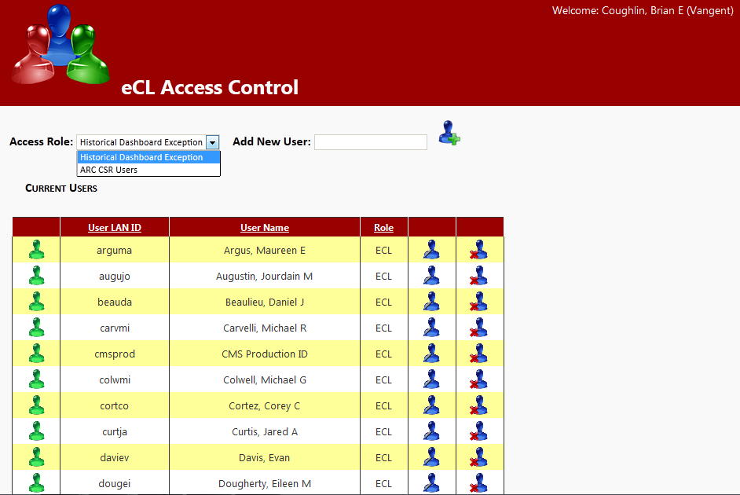

# System Generated Emails

The following rules determine when emails are sent when there are pending eCLs. In addition to being able to see pending eCLs within the user’s dashboards users receive an email notification letting them know that they have an item to take action on.

# Pending Supervisor Review

Conditions and email text that is sent when an eCL record is in the state of “Pending Supervisor Review”.

|  |  |  |  |
| --- | --- | --- | --- |
| **#** | **Form Type** | **Condition** | **Email Text** |
| 1 | Indirect | If ([strCoachReason_CSE] Is Not “Opportunity”)  And ([strSource] Is Not “Customer Service Escalation Tracking”)  Then [email text]  Note [strFormStatus] should = “Pending Supervisor Review” or strFormStatus = Pending Acknowledgment | strto = strCSRSupName <strCSRSupEmail>  strSubject = “eCL: Pending Supervisor Review (“ & strPerson & “)”  strCtrMessage = “A new eCoaching Log has been entered on behalf of <strong>strPerson</strong> on <strong>DateTime.Now().ToString </strong> that requires your action. Please click on the link below to review the eCoaching log. After you have reviewed and coached an email will go to “ & strPerson & “ with direction to review and verify the coaching opportunity.”  Strto = strCSRSupName <strCSRSupEmail>  strSubject = “eCL: Pending Acknowledgment (“ & strPerson & “)”  strCtrMessage = “A new eCoaching Log has been entered on behalf of <strong>strPerson</strong> on <strong>DateTime.Now().ToString </strong> that requires your action. Please click on the link below to review the eCoaching log. |

# 

# Pending Manager Review

Conditions and email text that is sent when an eCL record is in the state of “Pending Manager Review”.

|  |  |  |  |
| --- | --- | --- | --- |
| **#** | **Form Type** | **Condition** | **Email Text** |
| 1 | Indirect | If ([strCoachReason_CSE] Is “Opportunity”)  Or ([strSource] Is “Customer Service Escalation Tracking”)  Then [email text]  Note [strFormStatus] should = “Pending Manager Review” | strto = strCSRMgrName < strCSRMgrEmail >  strSubject = “eCL: Pending Manager Review (“ & strPerson & “)”  strCtrMessage = “A new eCoaching Log has been entered and requires your action. Please click on the link below to review and verify that the eCL entered on <strong>DateTime.Now().ToString</strong> for <strong>strPerson</strong> is a valid Customer Service Escalation (CSE). Further directions are provided on the form.” |
| 2 | Direct | If ([strCoachReason_CSE] Is “Opportunity”)  And ([strFormStatus] Is Not “Pending Manager Review”)  Then [email text]  Note [strFormStatus] should = “Pending Manager Review” | strto = strCSRMgrName < strCSRMgrEmail >  strSubject = “eCL: Pending Manager Review (“ & strPerson & “)”  strCtrMessage = “A new eCoaching Log has been entered and requires your action. Please click on the link below to review and verify that the eCL entered on <strong>DateTime.Now().ToString</strong> for strPerson is a valid Customer Service Escalation (CSE). Further directions are provided on the form.” |

# Pending CSR Review

Conditions and email text that is sent when an eCL record is in the state of “Pending CSR Review”.

|  |  |  |  |
| --- | --- | --- | --- |
| **#** | **Form Type** | **Condition** | **Email Text** |
| 1 | Indirect or Direct | If ([strFormStatus] Is “Pending CSR Review”)  And ([strFormType] Is “Indirect” Or “Direct”)  Then [email text] | strto = strCSRName <strCSREmail>  strSubject = “eCL: Pending CSR Review (“ & strPerson & “)”  strCtrMessage = “A new eCoaching Log has been entered on your behalf. Please click on the link below to review and verify the coaching opportunity received on <strong>DateTime.Now().ToString</strong>.” |

# No Email

Conditions and email text that is sent when an eCL record is in the state of “Pending CSR Review”.

|  |  |  |  |
| --- | --- | --- | --- |
| **#** | **Form Type** | **Condition** | **Email Text** |
| 1 | Indirect or Direct | If ([strCoachReason_CSE] Is Not “Opportunity”)  And ([strFormStatus] Is “Quality Specialist Coaching”)  Then Record status = “Completed” No email sent |  |

# Email Format

Details the email formatting and how the above conditions fill the email header and body.

|  |
| --- |
| To – [strto] |
| Subject – [strSubject] |
| ** This is an automated email. Do not reply to this email. **   [strCtrMessage]  [Link to Dashboard]  Form ID: [strFormID]  (Please do not respond to this automated notification)  Thank you, eCoaching Log Team http://cwe.vangent.local/sites/teams/CMS/CSR/eCoaching/SiteImages/BCC-eCL-LOGO-10142011-185x40.png |

# Outliers (Data Feed\Form Entry)

**eCoaching Log [Outlier Research and Coaching Process]**

The eCL outlier research and coaching process is a standard process to facilitate consistent communication when a performance opportunity exists. It provides a method to make a determination of whether coaching is needed, when to initiate coaching and verification that the performance issue has been addressed

# eCL Outlier Research and Coaching Assumptions

Outlier reports are created by the BCC Analytics team which identify thresholds and exceptions that require coaching or further research by Call Center Mangers (CCM). All items are entered into the eCL either through a Point of Contact (POC) via the standard entry form or through a data feed. Utilizing the eCL work-flow, items can be tracked from start to finish to verify if items have been addressed. The eCL will also provide reporting on the number of outliers entered into the system, the number coached, pending coaching, pending review or reasons why coaching was not required.

# eCL Outlier Research and Coaching Process

High level process map for the eCL Outlier Research and Coaching.

eCL Outlier Research and Coaching Process



# * POC for manual entry or data feed is to be determined though the Outlier/Exception Management Process project led by the BCC Analytics team.

* Manager represents the direct Manager or the direct report requiring coaching as defined in Peoplesoft and eWFM.

* Supervisor represents the direct Supervisor or the direct report requiring coaching as defined in Peoplesoft and eWFM.

* CSR represents the individual requiring coaching as defined in the outlier reporting.

# Outlier Reporting Matrix

The table below show all of the outlier reporting that will be entered into the eCL for direct coaching or manager review, the predetermined coaching thresholds and if items will be entered through the data feed or a POC. Only POC options will be available in the “*How was the coaching opportunity identified?”* question on the eCL entry form. Both POC and Data Feed types will be available in the Historical Dashboard dropdown list.

eCL Outlier Reporting Matrix

|  |  |  |  |  |  |  |
| --- | --- | --- | --- | --- | --- | --- |
| **#** | **Metric/Report** | **Coaching Threshold(s)** | **Code** | **eCL Workflow** | **Entry** | **Coaching Reason** |
| 1 | OMR: Inappropriate ACO Escalation |  | ACO | Direct Coach | POC | Current Coaching Initiatives |
| 2 | OMR: ACW |  | ACW | Direct Coach | POC | Current Coaching Initiatives |
| 3 | OMR: AHT |  | AHT | Direct Coach | POC | Current Coaching Initiatives |
| 4 | OMR: Cancelled Calls |  | CAN | Manager Review | Data Feed | Current Coaching Initiatives |
| 5 | OMR: Default Qualifiers |  | DFQ | Manager Review | Data Feed | Current Coaching Initiatives |
| 6 | OMR: Inappropriate ARC Escalation |  | IAE | Direct Coach | POC | Current Coaching Initiatives |
| 7 | OMR: Inappropriate DME Escalation |  | IDE | Direct Coach | POC | Current Coaching Initiatives |
| 8 | OMR: Inappropriate EE/MM Escalation |  | IEE | Direct Coach | POC | Current Coaching Initiatives |
| 9 | OMR: Inappropriate NGD Feedback |  | INF | Direct Coach | POC | Current Coaching Initiatives |
| 10 | OMR: ISG Consults |  | ISG | Manager Review | Data Feed | Current Coaching Initiatives |
| 11 | OMR: Short Calls – Inbound |  | ISQ | Manager Review | Data Feed | Current Coaching Initiatives |
| 12 | OMR: Low CSAT |  | LCS | Direct Coach | POC | Current Coaching Initiatives |
| 13 | OMR: Scripts Logged |  | SLG | Direct Coach | POC | Current Coaching Initiatives |
| 14 | OMR: NGD Inappropriate Transfer |  | NIT | Manager Review | Data Feed | Current Coaching Initiatives |
| 15 | OMR: Open Calls |  | OPN | Manager Review | Data Feed | Current Coaching Initiatives |
| 16 | OMR: Short Calls – Outbound |  | OSC | Manager Review | Data Feed | Current Coaching Initiatives |
| 17 | OMR: Returned MAC Escalation |  | RME | Direct Coach | POC | Current Coaching Initiatives |
| 18 | OMR: BCC Security and Privacy Incident Coaching |  | SPI | Direct Coach | POC | Current Coaching Initiatives |
| 19 | OMR: Transfers |  | TRN | Manager Review | Data Feed | Current Coaching Initiatives |

**Database**

Four fields were created which facilitate the workflow and data analysis of the outlier research and coaching process. A rejected table was created to capture records that have LAN IDs (strCSR) that are not found in the hierarchy table. The table below describes the fields:

New eCL Data Fields

|  |  |  |  |  |
| --- | --- | --- | --- | --- |
| **#** | **Field Name** | **Description** | **Data Type** | **Field Options** |
| 1 | strReportCode | * Outlier report code that corresponds to the specific report entered into the eCL (provided on the outlier report feed). | Text (string) | N/A |
| 2 | isCoachingRequired | * When research is required on an outlier item the call center manager must research the item and determine if it needs to be coached or if it is not coachable. | True/False (oolean) | N/A |
| 3 | strReasonNotCoachable | * Short reason for why item was not coachable | Text (string) | Other |
| 4 | txtReasonNotCoachable | * Long reason/explanation/justification as to why the item is not coachable. | Rich Text (XHTML) | N/A |

**Front-end Form**

The table below describes the changes made to the front end form.

eCL Outlier Research and Coaching Process Front-end Form Changes

|  |  |  |  |  |  |  |  |
| --- | --- | --- | --- | --- | --- | --- | --- |
| **#** | **Form Page** | | **Field** | **Conditional Format** | **Display Text** | **Control** | **Option (Value)** |
| 1 | Indirect Entry | | strSource | * If strFormType = ‘Indirect’ | N/A | Dropdown Menu | Choices:   * Returned MAC Escalation * Inappropriate DME Escalation * Inappropriate EE/MM Escalation * Low CSAT * Inappropriate NGD Feedback * Inappropriate ACO Escalation * Inappropriate ARC Escalation * BCC Security and Privacy Incident Coaching * LLP |
| * Conditions for Review pages | | | | | | | |
| 1 | | Manager Review | isCoachingRequired | * Show if [strCoachReason_ Current_Coaching_Initiatives] = ‘Research Required’ * Show only on form view: Manager Review | ‘You are receiving this eCL record because a CSR on your team was identified in an Outlier Management Report (OMR). Please research this item in accordance with the **Contact Center Operations 46.0 Outlier Management Report (OMR): Outlier Research Process SOP** and provide the details in the record below.”  Based off of your research does this record require coaching?’ | Radio Button | * Yes(True) * No (False)   Note: the hyperlink points to  <http://cwe.vangent.local/>  sites/teams/CMS/SOP/  Contact Center Operations/  CC_46.0 OMR Outlier  Research Process_v1 0.pdf |
| 2 | | Manager Review | strReasonNotCoachable | * Show if [isCoachingRequired] = False * Show only on form view: Manager Review * Dropdown menu * Default value = Other | ‘What was the main reason this item was not coachable?’ | Dropdown Menu | * Other (Other) |
| 3 | | Manager Review | txtReasonNotCoachable | * Show if [isCoachingRequired] = False * Show only on form view: Manager Review | ‘Please provide reason / explanation / justification as to why the item was not coachable:’ | Text Box | N/A |
| 4 | | Manager Review | txtDescription | * Details for the reason for the coaching (displayed under Coaching Reasons) | “Details of the behavior being coached” | Static TextBox | N/A |
| 5 | | Manager Review | txtMgrNotes | * Show if [isCoachingRequired] = True * Show only on form view: Manager Review | ‘Please provide reason / explanation / justification as to why the item is coachable for the Supervisor’ | Text Box | N/A |
| 6 | | Manager Review | MgrReviewManualDate | * Show only on form view: Manager Review * Do not allow future dates | ‘Date:’ | Date Picker | N/A |
| 7 | | Supervisor Review | txtMgrNotes | * Show if [isCoachingRequired] = True * Show only on form view: Supervisor Review * Read-only | ‘Notes from Manager’ | Text Box | N/A |
| 8 | | Supervisor Review | CoachingDate | * Show only on form view: Supervisor   Do not allow future dates | ‘Coaching Date’ | Date Picker | N/A |

If the log is of strSource type OMR and if the EmailSent attribute in the Coaching_Log table is Null\False, one of the following emails will be sent depending on the strFormStatus (Pending CSR Review, Pending Supervisor Review, Pending Manager Review. After the email is sent, the EmailSentAttribute is set to True.

The email formats for Outlier Pending Review are listed below:

**Manager-**

** This is an automated email. Do not reply to this email. **

A new eCoaching Log has been entered and requires your action. Please click on the link below to review and verify that the eCL entered on <strong>” & DateTime.Now() for ToString & “</strong> is a valid Customer Service Escalation (CSE). Further directions are provided on the form.   
  
[Please click here to open the eCL Dashboard](http://cwe.vangent.local/sites/teams/CMS/CSR/eCoaching/Pages/Dashboard.aspx)   
Form ID:   
  
(Please do not respond to this automated notification)   
  
Thank you,   
eCoaching Log Team   
http://cwe.vangent.local/sites/teams/CMS/CSR/eCoaching/SiteImages/BCC-eCL-LOGO-10142011-185x40.png

**Supervisor-**

** This is an automated email. Do not reply to this email. **

A new eCoaching Log has been entered on behalf of ToString & “</strong> on <strong>” & DateTime.Now() that requires your action. Please click on the link below to review the eCoaching log. After you have reviewed and coached an email will go to ToString & “</strong with direction to review and verify the coaching opportunity.   
  
[Please click here to open the eCL Dashboard](http://cwe.vangent.local/sites/teams/CMS/CSR/eCoaching/Pages/Dashboard.aspx)   
Form ID:   
  
(Please do not respond to this automated notification)   
  
Thank you,   
eCoaching Log Team   
https://vadenmwbp11.vangent.local/coach/images/BCC-eCL-LOGO-10142011-185x40.png

**CSR-**

** This is an automated email. Do not reply to this email. **

A new eCoaching Log has been entered on your behalf. Please click on the link below to review and verify the coaching opportunity received on 6/28/2013. Opportunity.   
  
[Please click here to open the eCL Dashboard](http://cwe.vangent.local/sites/teams/CMS/CSR/eCoaching/Pages/Dashboard.aspx)   
Form ID:   
  
(Please do not respond to this automated notification)   
  
Thank you,   
eCoaching Log Team   
http://cwe.vangent.local/sites/teams/CMS/CSR/eCoaching/SiteImages/BCC-eCL-LOGO-10142011-185x40.png

**On Form Submit for Review update if**

|  |  |  |  |
| --- | --- | --- | --- |
| **#** | **Form Page** | **Field** | **Conditional Format** |
| 1 | Manager Review | On Submit | * Set [MgrReviewAutoDate] to current date and time * If [isCoachingRequired] = True then set [strCoachReason_ Current_Coaching_Initiatives] to ‘Opportunity’ * and set [strFormStatus] to ‘Pending Supervisor Review’ * If [isCoachingRequired] = False then set [strCoachReason_ Current_Coaching_Initiatives] to Not Coachable * and set [strFormStatus] to ‘Inactive’ |
| 2 | Supervisor Review | On Submit | * Set [strFormStatus] to ‘Pending CSR Review’ * Set [SupReviewedAutoDate] to current date and time |
| 3 | CSR Review | On Submit | * Set [strFormStatus] to ‘Complete’ * Set [CSRReviewAutoDate] to current date and time |

**Dashboards**

The table below describes the dashboard modifications for outliers.

|  |  |  |  |  |  |  |
| --- | --- | --- | --- | --- | --- | --- |
| **#** | **Dashboard** | **Field** | **Conditional Format** | **Display Text** | **Control** | **Option (Value)** |
| 1 | All |  | * If [strFormStatus] = ‘Inactive’ then hide |  |  |  |
| 2 | All as needed | Source |  | • Inbound Short Calls  • Returned MAC Escalation  • Inappropriate DME Escalation  • Inappropriate EE/MM Escalation  • Low CSAT  • Inappropriate NGD Feedback  • Default Qualifiers  • ISG Consults  • Inappropriate ACO Escalation  • Transfers  • Inappropriate ARC Escalation  • Outbound Short Calls  • Cancelled Calls  • Open Calls  • NGD Inappropriate Transfer  • BCC Security and Privacy Incident Coaching  • LLP |  |  |

*If a record has a strFormStatus of “Inactive”, hide it from all dashboards. eCoaching Logs for employees that have a hierarchy Active status of T or D are set to strFormStatus “Inactive”, immediately after receiving the employee Active status change from Peoplesoft.

File Layout:

| **Element #** | **Field Name** | **Max Length / Field Format** | **Description** |
| --- | --- | --- | --- |
|  | numReportID | Numeric | Report ID is the unique indicator for the table. |
|  | strReportCode | 20 bytes, 3 letter report code + CCYYMMDD | Outlier report code that corresponds to the specific report and date. (ACO,ACW,AHT,CAN,DFQ,IAE,IDE,IEE,INF,ISG,ISQ,LCS,SLG,NIT,OPN,OSC,RME,SPI,TRN) |
|  | strFormType | 20 bytes, Alpha | Indirect |
|  | strSource | 60 bytes, Alpha/Numeric | Report Name (OMR: Inappropriate ACO Escalation,OMR: ACW,OMR: AHT,OMR: Cancelled Calls,OMR: Default Qualifiers,OMR: Inappropriate ARC Escalation,OMR: Inappropriate DME Escalation,OMR: Inappropriate EE/MM Escalation,OMR: Inappropriate NGD Feedback,OMR: ISG Consults,OMR: Short Calls – Inbound,OMR: Low CSAT,OMR: Scripts Logged,OMR: NGD Inappropriate Transfer,OMR: Open Calls,OMR: Short Calls – Outbound,OMR: Returned MAC Escalation,OMR: BCC Security and Privacy Incident Coaching,OMR: Transfers) |
|  | strFormStatus | 30 bytes, Alpha | Status of the evaluation (Pending CSR Review,Pending Manager Review,Pending Supervisor Review) |
|  | EventDate | 10 bytes, MM/DD/CCYY | The date when the incident occurred.e CSR’s sentuator IDcard as an opportunity or reinforcement |
|  | SubmittedDate | 10 bytes, MM/DD/CCYY | The date when the evaluation is created.  e CSR’s sentuator IDcard as an opportunity or reinforcement |
|  | StartDate | 10 bytes, MM/DD/CCYY | The date when work begins on the evaluation. |
|  | strSubmitterName | 30 bytes, Alpha/Numeric | Name of the submitter. |
|  | strSubmitterEmail | 50 bytes, Alpha/Numeric | eMail address of the submitter. |
|  | strCSR | 30 bytes. Alpha/Numeric | LAN ID of the CSR |
|  | strCSRSite | 20 bytes. Alpha | Name of the CSRs site. |
|  | strCoachReason_Current_Coaching_Initiatives | 20 bytes, Alpha | Not Coachable  Opportunity  Reinforcement  Research Required |
|  | txtDescription | 3000 bytes, Alpha/Numeric | Details for the reason for the Coaching |

Sample Outlier Feed:  
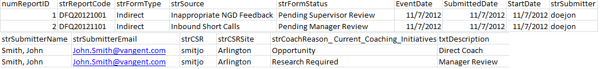

# IQS (Data Feed\Form Entry)

IQS Lime Survey is the source system for quality eCoaching Logs. A Pending Acknowledgment strFormStatus flow has been added to handle IQS records that have completed coaching outside of the eCL application and only require the CSR and Supervisor to sign off on the acknowledgment portion.

eCL IQS Research and Coaching Process

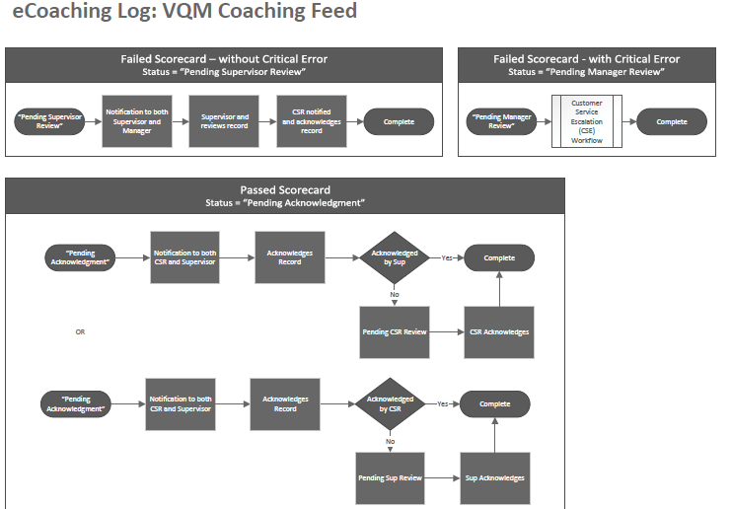

File Layout:

| **Element #** | **Req** | **Field Name** | **Max Length / Field Format** | **Description** |
| --- | --- | --- | --- | --- |
|  | * | Evaluation ID | 20 bytes, Alpha/Numeric | Evaluation ID is the unique indicator for the scorecard. This should be a natural key back to the source system.  A field was added to the Coaching_Log table to capture this value:  strIQS_EvalID nvarchar(20) |
|  | * | Evaluation Date | 19 bytes, (MM/DD/CCYY HH:MI:SS) | The date and time when the evaluation is created. This will be the system calculated date and local time of the site where the evaluation is first saved.  Cannot be future dated. |
|  | * | Evaluation Site ID | 3 bytes, Numeric | The site where the scorecard is created. Valid site IDs are:  32 – Lawrence  33 – Iowa City  35 – Phoenix  84 – Richmond  85 – Corbin  278 – Tampa  11 – Test server  A field was added to the Coaching_Log table to capture this value:  numIQS_EvalSiteID int |
|  | * | CSR Emp ID | 20 bytes, Alpha/Numeric | Employee ID for the CSR |
|  | * | CSR Emp ID | 20 bytes, Alpha/Numeric | Employee ID for the CSR |
|  | * | Supervisor Emp ID | 20 bytes, Alpha/Numeric | Supervisor’s Employee Ide CSR’s sentuator IDcard as an opportunity or reinforcement |
|  | * | Supervisor Emp ID | 20 bytes, Alpha/Numeric | Supervisor’s Employee Ide CSR’s sentuator IDcard as an opportunity or reinforcement |
|  | * | Manager Emp ID | 20 bytes, Alpha/Numeric | Manager’s Employee ID |
|  | * | Manager Emp ID | 20 bytes, Alpha/Numeric | Manager’s Employee ID |
|  |  | Journal File Number | 30 bytes, Alpha/Numeric | An ID associated to the original voice and data recordings referring to the number assigned to the call. (Note this is not the Token)  Typically this is the Mattersite ID from Lime Survey.  Cannot be Null, Blank or NA for PpoM and QCM but can be blank otherwise. |
|  | * | Call Date / Time | 19 bytes. (MM/DD/CCYY HH:MI:SS) | System generated date/time of the call for evaluations with valid call content. If there is no valid call content this field will be populated with the current date generated when the query is run. |
|  | * | BLANK | 19 bytes. (MM/DD/CCYY HH:MI:SS) | Previously Coaching Date |
|  | * | Summary of Caller’s Issues  **PLUS**  Coaching/Goal Discussion | 6150 bytes, Alpha/Numeric Non-alphanumeric characters are removed. | Reason why the Beneficiary called.  This goes into Details of Behavior being Coached in the front end.  **PLUS**  Notes for coaching discussions with the CSR.  From “Summary of Coaching Priorities” comment field on the form.  NA will be populated in this field if not populated by the user.  An appealed record will be identified by an “A-“ appended at the beginning of any text in this field.  These 2 sections will be separated in the feed by:  **<Carriage Return>**  **COACHING NOTES**  Note: When IQS feeds are received, containing updated logs that are still Open in our system, this field will be updated to match the newest feed. |
|  | * | Blank | 4000 bytes, Alpha/Numeric Non-alphanumeric characters are removed. | Formerly Coaching/Goal Discussion:  Notes for coaching discussions with the CSR.  From “Summary of Coaching Priorities” comment field on the form.  NA will be populated in this field if not populated by the user.  An appealed record will be identified by an “A-“ appended at the beginning of any text in this field. |
|  |  | Customer Service Assessment Critical Error | 2 bytes, Alpha/Numeric | Critical Error code for Customer Service Assessment or Writing Skills Assessment.  Valid QCM values: 1, 2, 3, 4, 5, 6, 7, 8, or Blank (for NA).  Default value: Blank |
|  | * | Evaluator ID | 20 bytes, Alpha/Numeric | The User ID of the person who created the evaluation. This is mapped to **Submitter** in eCL. |
|  |  | Blank | 25 bytes, Alpha/Numeric | Formerly Coached by Name: name of the person performing the coaching |
|  | * | Blank | 20 bytes, Alpha/Numeric | Formerly Coacher Emp ID:User ID of the person who performed the coaching.  Will cross match to confirm the ID exists in the Person table. |
|  | * | Blank | 30 bytes, Alpha/Numeric | Formerly Source: Valid values will be based on the Role Code for the Coacher.  QAA role code = IQS Feed Quality Specialist  SUPR role code = IQS Feed Supervisor  All other role codes = IQS Feed Other |
|  | * | Blank | 10 bytes, Alpha/Numeric | Formerly CSR Signature: Emp ID of the CSR being coached.  Will contain ‘XXXXX’ if the CSR has refused to sign.  Will cross match to confirm the ID exists in the Person table. |
|  | * | Opportunity / Reinforcement | 17 bytes, Alpha/Numeric | Value calculated from the section overall scores within the scorecards.  Valid values:  Opportunity  Reinforcement  Opportunity-PWC  Met goal  Did not meet goal  Note: When IQS feeds are received, containing updated logs that are still Open in our system, this field (strCoachReason_Quality) will be updated to match the newest feed. |

**\*** Cannot be Null, Blank or NA

# Sample IQS Feed:

# 15699|08/13/2013 22:44:03|35|221199|221199|413599|413599|403099|403099|74169990|08/05/2013 13:44:00||Phone – Beneficiary is calling to verify if Medicare covers dental services. |Excellent job John.|||||||reinforcement

Bottom of Form

Peoplesoft Feed:

|  |  |  |  |  |
| --- | --- | --- | --- | --- |
| lanid | emplid | first_name | middle_name | last_name |
| First.Last | W999999 | First | M | Last |
|  |  |  |  |  |
| locationid | location |  | supervisorid | managerid |
| WMS23 | MS-Hattiesburg-5912 Highway 49 |  | W111111 | W222222 |
|  |  |  |  |  |
| jobcodeid | jobcode | email_addr | empl_status |  |
| WACS01 | Assoc Specialist, Cust Svc | [First.Last@GDIT.com](mailto:First.Last@GDIT.com) | T |  |

# Other System Attributes

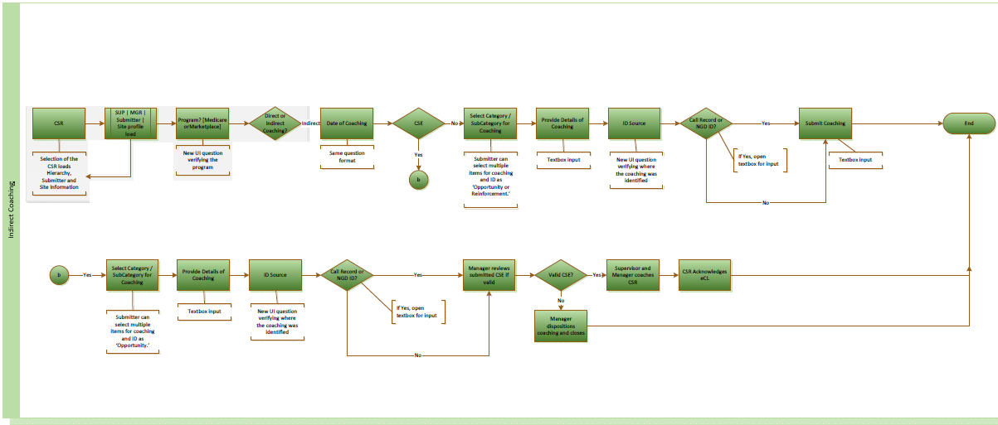

## Historical Reporting Access Controls

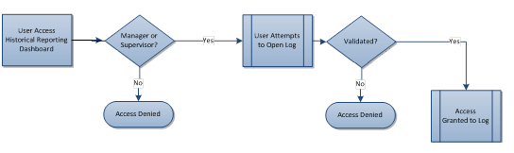

# Method for Change Management

This document will be stored in Sharepoint. It’s minor version number will be updated when changes are made.